A000-AM,C-Taino-Celt-Dove Cemi-Andesite-1000 CE

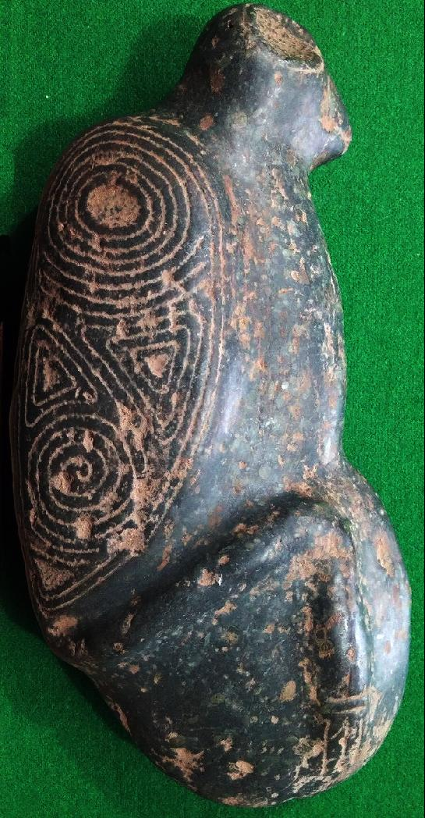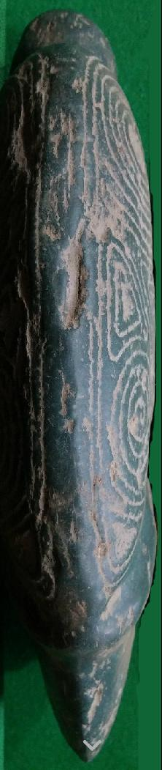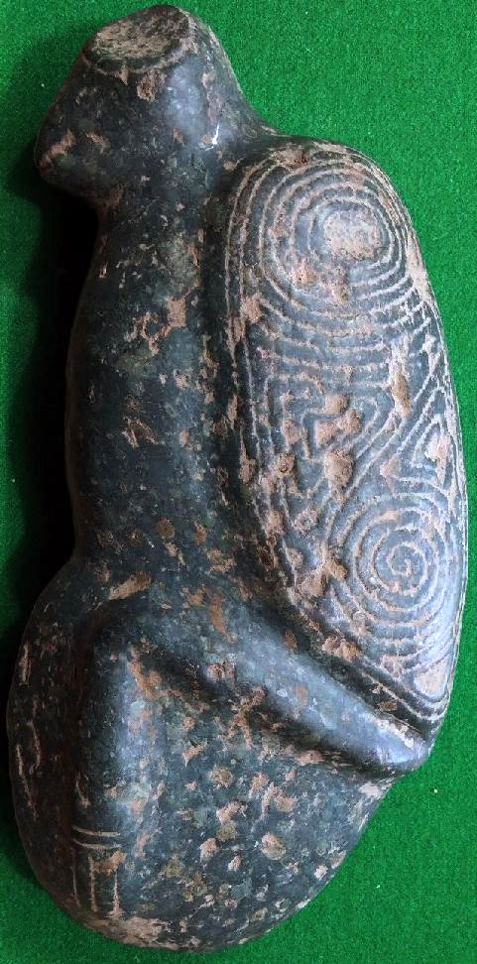

Figs. 1-3. AM,C-Taino-Celt-Dove Cemi-1000 CE

Case No.: 18

**Accession No.**

**Formal Label:** AM,C-Taino-Celt-Dove Cemi-1000 CE

**Display Description:**

Ceremonial *cemí* carved from andesite with zeolite crystal inclusions in the form of possibly a dove. The wings provide three geometric forms: concentric circles for the sun god, triangles for the *conucos* or yucca mounds the source of sacred food, and spirals for the passage of wind and rain in the *hurrican* season to fructify the earth with water. In a lost mythology the bird sculptured here (probably a dove) was possibly the harbinger of the coming of the rainy *hurrican* season.

**LC Classification: F1909**

**Date or Time Horizon: 1000 CE**

**Geographical Area: Caribbean, Classic Taino Area**

**Map:**

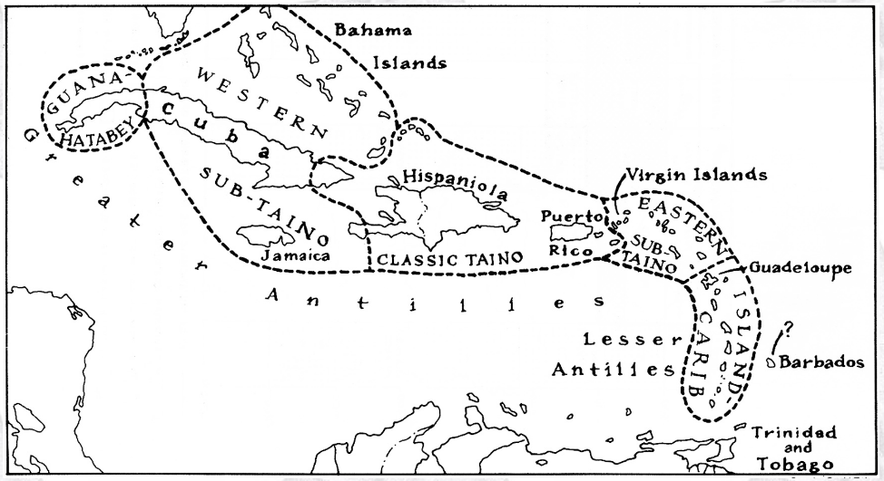

**Caribbean c 1500 after http://www.latinamericanstudies.org/maps/Ciboney-Taino-Carib-map.jpg**

**Cultural Affiliation: Classic Taino**

**Media:**

**Dimensions:**

**Weight:**

**Condition:**

**Provenance:**

**Discussion:**

**References:**

Bower, B

1994 Maya Beginnings Extend Back at Belize Site. Science News 145(18):279.

Bullen, R. P.

1976 The Preceramic Periods of Florida and the Lesser Antilles. In Proceedings of the First Puerto Rican Symposium on Archaeology, edited by L. S. Robinson, pp. 9-23. Fundacion Arqueologica, Antropologica e Historica de Puerto Rico, San Juan

Callaghan, R. T.

1990 Possible Pre-ceramic Connections between Central America and the Greater Antilles. Proceedings of the Eleventh Congress of the International Association for Caribbean Archaeology,

1985, pp. 65-71, Puerto Rico.

1991 Passage to the Greater Antilles: An Analysis of Watercraft and the Marine Environment. Proceedings of the Fourteenth Congress of the International Association for Caribbean Archaeology, 1989, pp. 64-72, Barbados

Coe, W. R., II

1957 A Distinctive Artifact Common to Haiti and Central America. American Antiquity 22:280-282.

Cruxent, J. M., and I. Rouse

1969 Early Man in the West Indies. Scientific American 221(5):42-52.

Gerrell, P. R., J. F. Scarry, and J. S. Dunbar

1991 Analysis of Early Archaic Unifacial Adzes from North Florida. The Florida Archaeologist 44(1):3-16.

Giménez Fernández, Manuel.

1971. "Fray Bartolomé de Las Casas: A Biographical Sketch". In Friede, Juan; Keen, Benjamin (eds). Bartolomé de las Casas in History: Toward an Understanding of the Man and his Work. Collection spéciale: CER. DeKalb: Northern Illinois University Press. pp. 67–126.

Hester, T. R.

1994a An Introduction to the Colha Preceramic Project.

Paper presented at the 59th Annual Meeting of the Society for American Archaeology, Anaheim.

1994b The Archaeological Investigations of the Colha Project, 1983 and 1984. In Continuing Archaeology at Colha, Belize, edited by T. R. Hester, H. J. Shafer, and J. D. Eaton, pp. 1-9. Texas Archaeological Research Laboratory, University of Texas, Austin.

Hester, T. R., H. J. Shafer, and T. C. Kelly

1980 A Preliminary Note on Artifacts from Lowe Ranch:

A Preceramic Site in Belize. In The Colha Project Second Season, 1980 Interim Report, edited by T. R.

Hester, J. D. Eaton, and H. J. Shafer.

1992. Center for Archaeological Research, University of Texas, San Antonio, and Centro Studi Ricerche Ligabue, Venezia. San Antonio.

Hester, T. R., H. Iceland, D. Hudler, R. Brewington, H. J. Shafer, and J. Lohse

1993 New Evidence on the Preceramic Era in Northern Belize: A Preliminary Overview. The Newsletter of the Friends of the Texas Archeological Research Laboratory 1(2): 19-23.

Hester, T. R., H. Iceland, D. Hudler, and H. J. Shafer

1996 The Colha Preceramic Project. Mexicon XVIII (3): 50.

Hudler, D. B., T. R. Hester, and H. B. Iceland

1995 The Colha Preceramic Project: A Status Report.

Paper presented at the 60th Annual Meeting of the Society for American Archaeology, Minneapolis.

Iceland, H. B., and T. R. Hester

1996a The Colha Preceramic Project: A Status Report.

Paper presented at the 61st Annual Meeting of the Society for American Archaeology, New Orleans.

1996b The Earliest Maya? Origins of Sedentism and Agriculture in the Maya Lowlands. Preprints of the XIII International Congress of the Prehistoric and Protohistoric Sciences, Forli, Italy, September 1996, in press.

Iceland, H. B., T. R. Hester, H. 1. Shafer, and D. Hudler

1995 The Colha Preceramic Project: A Status Report. The Newsletter of the Friends of the Texas Archeological Research Laboratory 3(2): 11-15.

Jacob, J. S.

1995 Ancient Maya Wetland Agricultural Fields in Cobweb Swamp, Belize: Construction, Chronology, and Function. Journal of Field Archaeology 22: 175-190.

Jones, J. G.

1994 Pollen Evidence for Early Settlement and Agriculture in Northern Belize. Palynology 18: 205-211.

Kelly, T. C.

1993 Preceramic Projectile-Point Typology in Belize.

Ancient Mesoamerica 4:205-227.

Lohse, 1. C.

1993 Operation 4046 Colha. Belize: A Reconsideration of a Lowland Archaic Deposit. Unpublished M.A. Thesis, Department of Anthropology, University of Texas, Austin.

MacNeish, R, S., and A. Nelken-Turner

1983 Final Report of the Belize Archaic Archaeological Reconnaissance. Center for Archaeological Studies, Boston University, Boston.

MacNeish, R. S., 1. K. Wilkerson, and A. Nelken-Turner 1980 First Annual Report of the Belize Archaeological Reconnaissance. Phillips Academy, Andover.

Mendez, Eugenio Fernandez. 1957. Crónicas de Puerto Ricao desde la conquista hasta nuestros dias. San Juan, Ediciones del Gobierno estado Libre Asociado de Puerto Rico.

Moore, C.

1991 Cabaret: Lithic Workshop Sites in Haiti. In Pro­ceedings of the Thirteenth Congress of the International Association for Caribbean Archaeology, edited by 1. Haviser and E. N. Ayubi, pp. 92-104. Reports of the Archaeological-Anthropological Institute of the Netherlands Antilles, No.9. Willemstad, Curacao.

Oliver, J. R. 2009. Caciques and cemi idols: the web spun by Taíno rules between Hispaniola and Puerto Rico. Tuscaloosa: University of Alabama Press.

Pané, Fray Ramón. *An Account of the Antiquities of the Indians.* Trans. José Juan Arrom and Susan C. Griswold. Durham: Duke UP, 1999.

Pantel, A. G.

1988 Precolumbian Flaked Stone Assemblages in the West Indies. Ph.D. dissertation, University of Tennessee. University Microfilms, Ann Arbor.

1991 How Sophisticated was 'the Primitive'? Pre-ceramic Source Materials, Lithic Reduction Processes, Cultural Contexts and Archaeological Inferences. Proceedings of the Fourteenth Congress of the International Association for Caribbean Archaeology, pp. 157-169. Barbados.

1994 Prismatic Blade Technologies in North America. In Organization of North American Prehistoric Chipped ­Stone Tool Technologies, edited by P. 1. Carr, pp. 87-98. Archaeological Series NO.7. International Monographs in Prehistory, Ann Arbor.

Peterson, J. B., C. L. Hofman, and L. A. Curet. 2004. Time and culture: chronology and taxonomy in the eastern Caribbean and the Guianas, in A. Delpuech and C. L. Hofman, eds., Late Ceramic age societies in the eastern Caribbean (British Archaeological Reports international series 1273): 17-32. Oxford: Archaeopress.

Rouse, I.

1941 Culture of the Ft. Liberti Region, Haiti. Yale University Publications in Anthropology, No. 26. New Haven.

1960 The Entry of Man into the West Indies. Yale University Publications in Anthropology, No. 61. New Haven.

1964 Prehistory of the West Indies. Science 144: 499-513.

1986 Migrations in Prehistory. Yale University Press, New Haven.

1992 The Tainos. Yale University Press, New Haven.

Shafer, H.

1991 Late Preclassic Formal Tool Production at Colha, Belize. In Maya Stone Tools, edited by T. R. Hester, H. 1. Shafer, and 1. D. Eaton, pp. 25-30. Texas Archaeological Research Laboratory, University of Texas. Austin.

Shafer, H. 1., T. R. Hester, and T. C. Kelly

1980 Notes on the Sand Hill Site. In The Colha Project Second Season, 1980 Interim Report, edited by T. R. Hester, 1. D. Eaton, and H. 1. Shafer, pp. 233-240. Center for Archaeological Research, University of Texas, San Antonio, and Centro Studi Ricerche Ligabue. Venezia.

Steward. 1. H.

1948 The Circum-Caribbean Tribes: An Introduction. In Handbook of South American Indians, vol. 4, The Circum-Caribbean Tribes, edited by 1. H. Steward, pp. 1--41. Bureau of American Ethnology Bulletin 143(4), Washington, D.C.

Stuiver, M., and R. S. Kra

1986 Calibration Issue, Proceedings of the 12th International 14C conference. Radiocarbon 28: 805-1030.

Stokes, A. v.. and W. F. Keegan

1993 A Settlement Survey for Prehistoric Archaeological Sites on Grand Cayman. Miscellaneous Project Report Number 52, Florida Museum of Natural History, Gainesville.

Veloz Maggiolo, M.

1976 Medioambiente y adaptacion humana en La prehis­toria de Santo Domingo. Universidad Autnoma de Santo Domingo, Santo Domingo, Republica Dominicana.

Veloz Maggiolo, M., and B. Vega

1982 The Antillean Pre-ceramic: A New Approximation.

Journal of New World Archaeology 5(2):33--44.

Wilson, S. M.

1996 The Rise of Complex Societies in the Caribbean.

Preprints of the XIII International Congress of the Prehistoric and Proto historic Sciences, Forlf, Italy. September 1996.

Wilson, Samuel M., Harry B. Iceland and Thomas R. Hester 1998 Preceramic Connections between Yucatan and the Caribbean Latin American Antiquity, Vol. 9, No.4 (Dec.), pp. 342-352.

Wood, G. P.

1990 Excavations at OP 4046, Colha, Belize: A Buried Preceramic Lithic Deposit. Unpublished M.A. thesis, Department of Anthropology, University of Texas, Austin.

Zeitlin, R. N.

1984 A Summary Report on Three Seasons of Field Investigations into the Archaic Period Prehistory of Lowland Belize. American Anthropologist 86:358--368.

Zeitlin, R. N., and 1. F. Zeitlin

1996 The Paleoindian and Archaic Cultures of Mesoamerica. In The Cambridge History of the Native Peoples of the Americas, edited by R. E. W. Adams and M. MacLeod. Cambridge University Press, Cambridge.

# Order details

## Sales order

Sold by [user1billion](http://myworld.ebay.com/user1billion) ( [787](http://feedback.ebay.com/ws/eBayISAPI.dll?ViewFeedback&userid=user1billion) )

### Delivery package 1 of 1

Estimated delivery Tuesday, Jan 26, 2016 - Tuesday, Feb 2, 2016

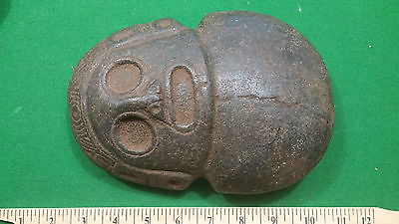

#### [Taino Stone Carving - Pre Columbian Very Large Double Edged Axe Head](http://www.ebay.com/itm/272098227060)

|  |  |
| --- | --- |
| Item price | $449.00 |
| Quantity | 1 |
| Item number | 272098227060 |
| Shipping service | Standard Int'l Shipping |

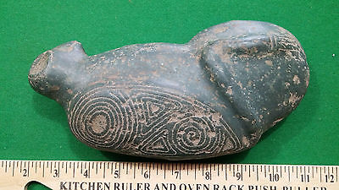

#### [Taino Stone Carving Axe Head - Pre Columbian](http://www.ebay.com/itm/272098227121)

|  |  |
| --- | --- |
| Item price | $259.00 |
| Quantity | 1 |
| Item number | 272098227121 |
| Shipping service | Standard Int'l Shipping |

## Shipping address

Ralph J Coffman Jr

149 Atlantic Ave

Swampscott MA 01907-2427

United States

## Order total

|  |  |
| --- | --- |
| Subtotal | $708.00 |
| Shipping | $39.90 |

**Total**

$747.90